| Universidade Federal do Ceará |  |
| --- | --- |
| General information   * Foundation year * Student number * Subject areas * Faculties name * Number of the university campus * Other relevant information |  |
| 5 University photographs |  |
| [www.ufc.br](http://www.ufc.br) |  |

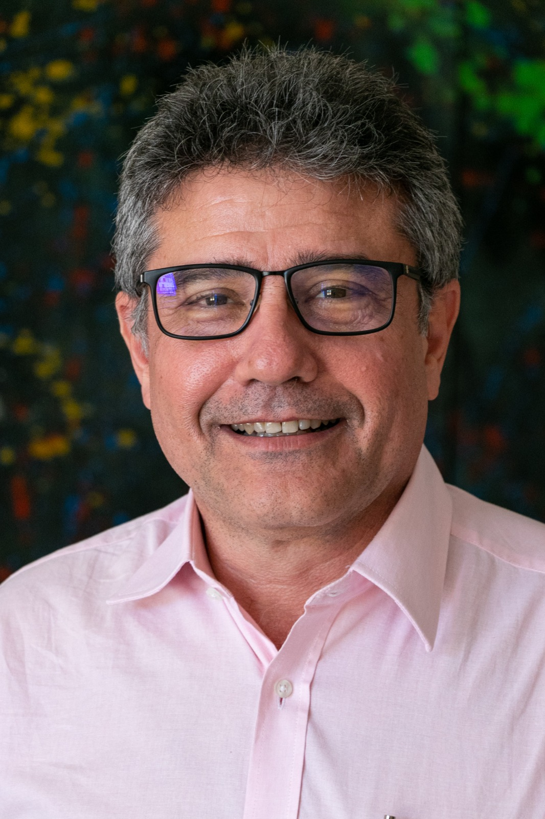

Full Name**: José de Paula Barros Neto**

Google Scholar link: <https://scholar.google.com/citations?hl=pt-BR&user=JDQBvNAAAAAJ>

Linkedin link: <https://www.linkedin.com/in/jos%C3%A9-p-barros-neto-0aa0161a/>

Email: [jpbarros@ufc.br](mailto:jpbarros@ufc.br)

Area of Expertise: Construction Management

Faculty: Technology Center

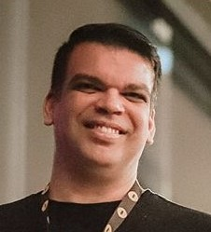

Full Name: **Raphael Amaral da Câmara**

Google Scholar link: <https://scholar.google.com/citations?hl=en&authuser=1&user=wpOv2tcAAAAJ>

Linkedin link: <https://www.linkedin.com/in/raphael-amaral-da-c%C3%A2mara-899a58197/>

Email: [raphael@dee.ufc.br](mailto:raphael@dee.ufc.br)

Area of Expertise: Energy Efficiency, Energy Market, Power Electronics with Renewable Sources of Energy Applications

Faculty: Technology Center

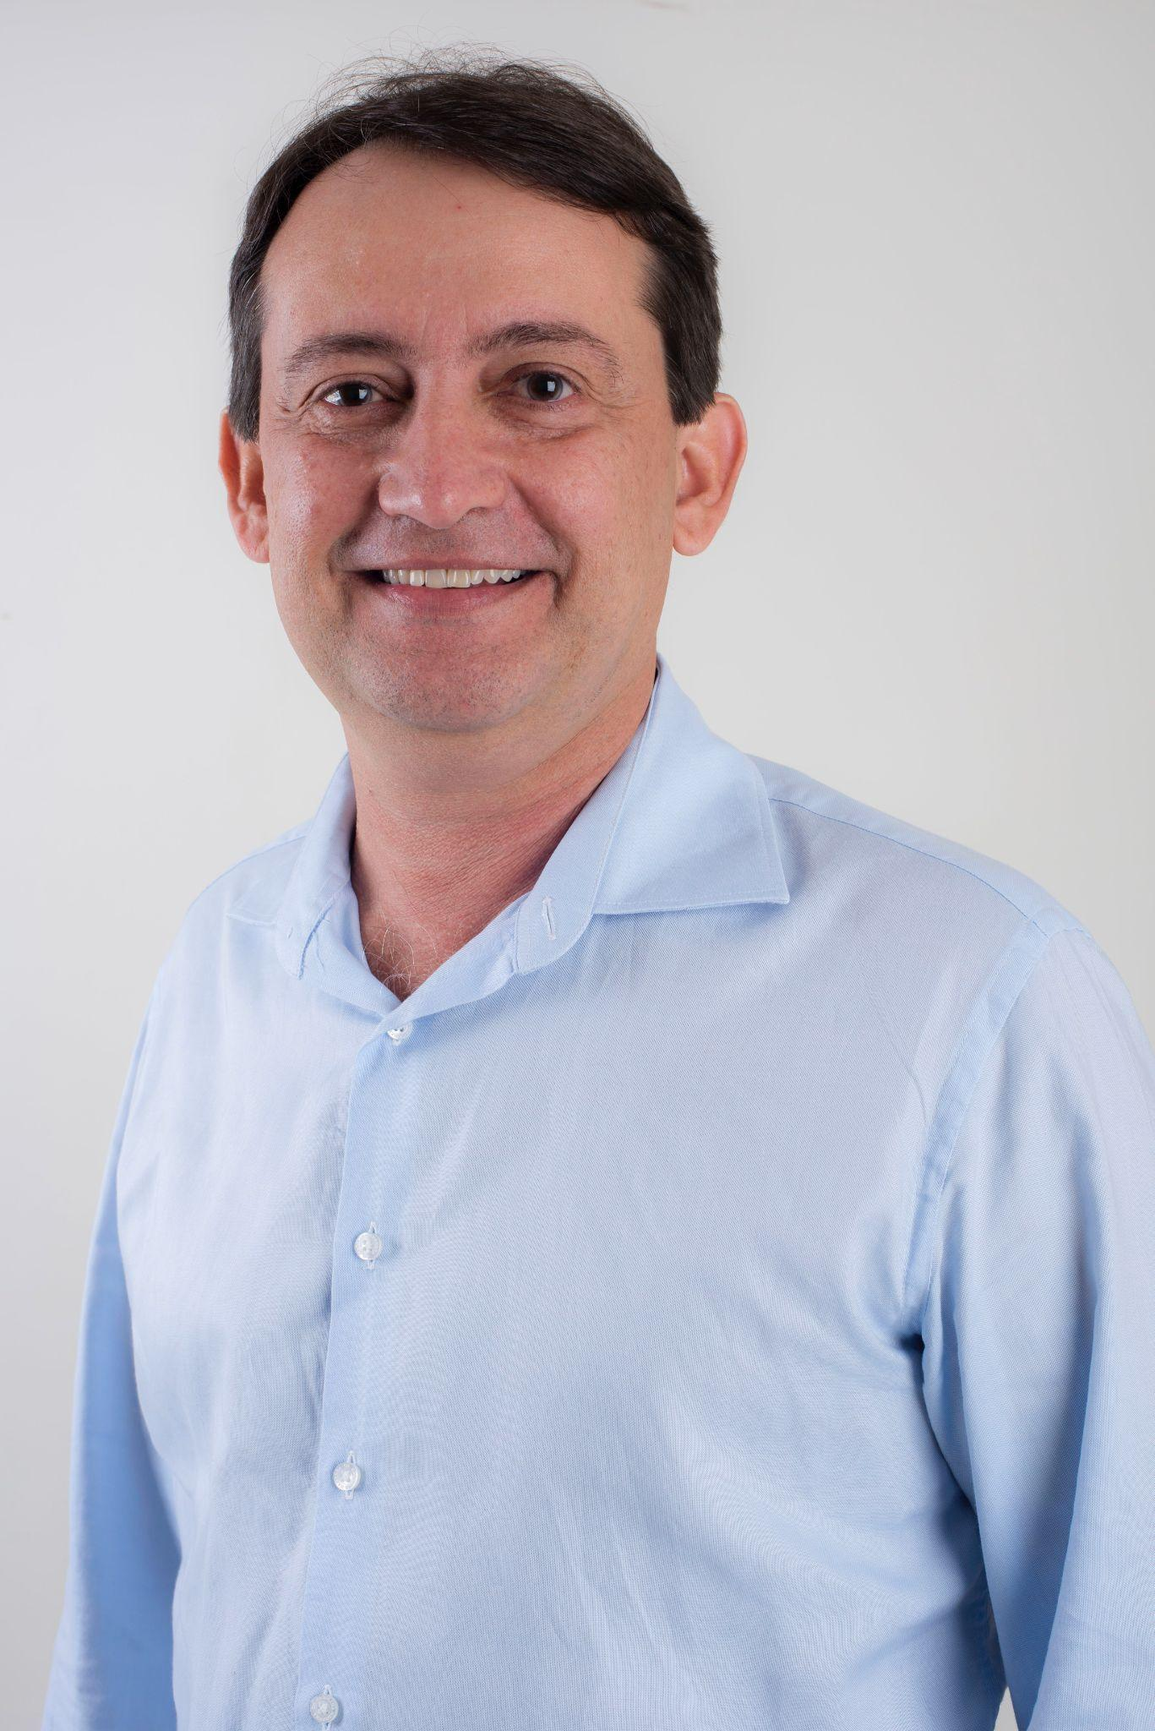

Full Name: **Carlos Almir Monteiro de Holanda**

Google Scholar link: <https://scholar.google.com.br/citations?hl=pt-BR&view_op=list_works&gmla=ABOlHiyzK2PfICeZ4gAw51oUgTY77J8wFwMItvTixAbHneueXX_2CBoE_t6srVkVOq0ULB7BfX4P_1linR2NmTeNOmEn_oJu&user=QVJpDpkAAAAJ>

Linkedin link: x-x-x

Email: [almir@ufc.br](mailto:almir@ufc.br)

Area of Expertise: Energy and exergetic analysis of thermal systems

Faculty: Technology Center

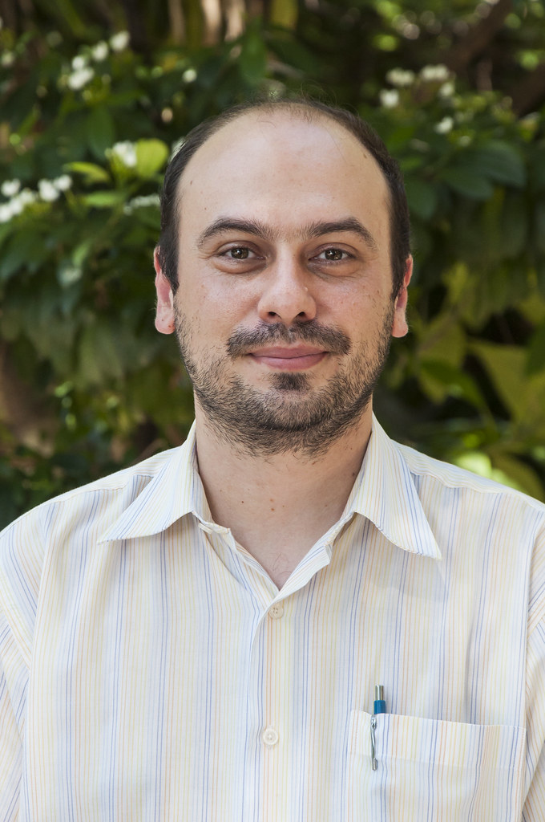

Full Name: **Bruno Vieira Bertoncini**

Google Scholar link: <https://scholar.google.com.br/citations?user=Dlo6szoAAAAJ&hl=pt-BR>

Linkedin link: x-x-x

Email: [bruviber@det.ufc.br](mailto:bruviber@det.ufc.br)

Area of Expertise: Transport Engineering; Environmental Impacts and Transports; Logístic

Faculty: Technology Center

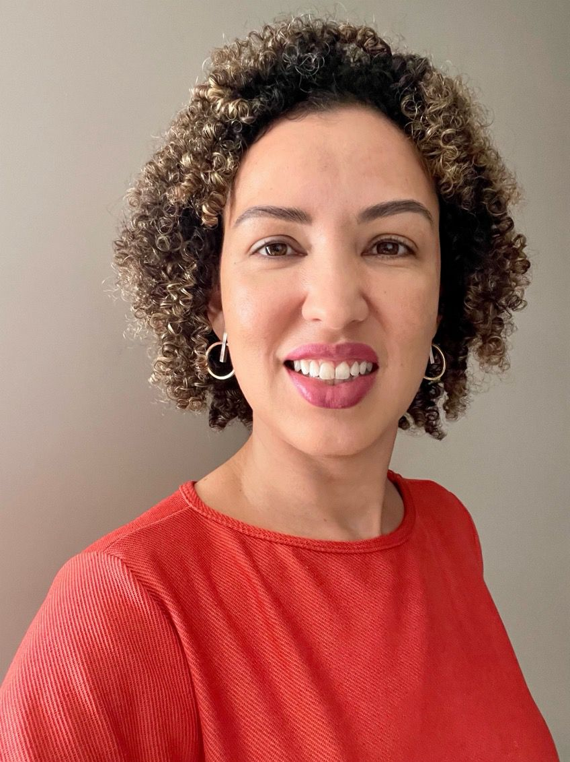

Full Name: **Mariana Monteiro Xavier de Lima**

Google Scholar link: <https://scholar.google.com.br/citations?user=7WL4dC8AAAAJ&hl=pt-BR>

Linkedin link: [www.linkedin.com/in/mariana-lima-76768631](http://www.linkedin.com/in/mariana-lima-76768631)

Email: [mariana@daud.ufc.br](mailto:mariana@daud.ufc.br)

Area of Expertise: Design methods; Digital Design; Building Information Modeling; Performance-based Design

Faculty: Technology Center

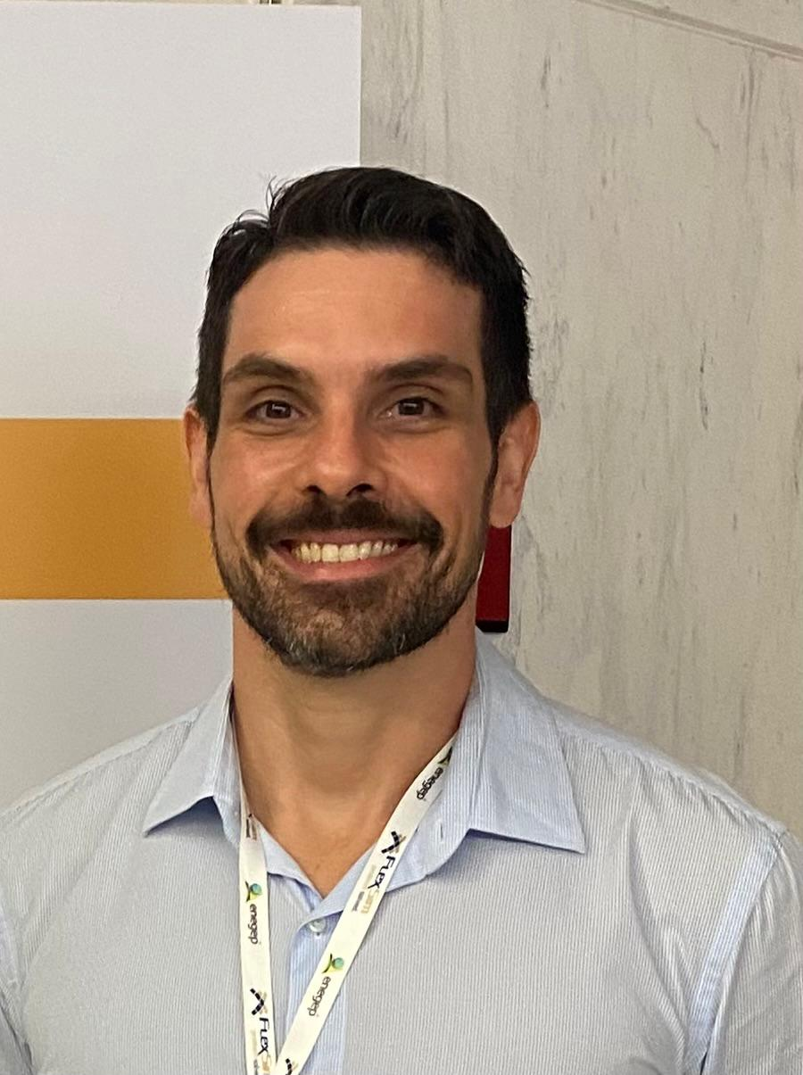

Full Name: **Breno Barros Telles do Carmo**

Google Scholar link: <https://scholar.google.com.br/citations?user=XRnzUAEAAAAJ&hl=pt-BR>

Linkedin link: -

Email: [brenobarros@ufc.br](mailto:brenobarros@ufc.br)

Area of Expertise: decision-making making, Social Life Cycle Assessment

Faculty: Technology Center

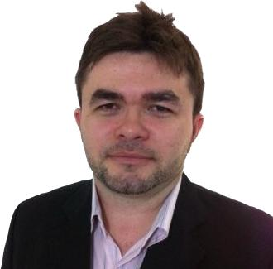

Full Name: **Danielo Gonçalves Gomes**

Google Scholar link: <https://scholar.google.com.br/citations?user=aQOP-o8AAAAJ&hl=en>

Linkedin link: <https://www.linkedin.com/in/dggomes/>

Email: [danielo@ufc.br](mailto:danielo@ufc.br)

Area of Expertise: data science applied to digital agriculture/beekeeping, digital transformation, and health;

Faculty: Technology Center

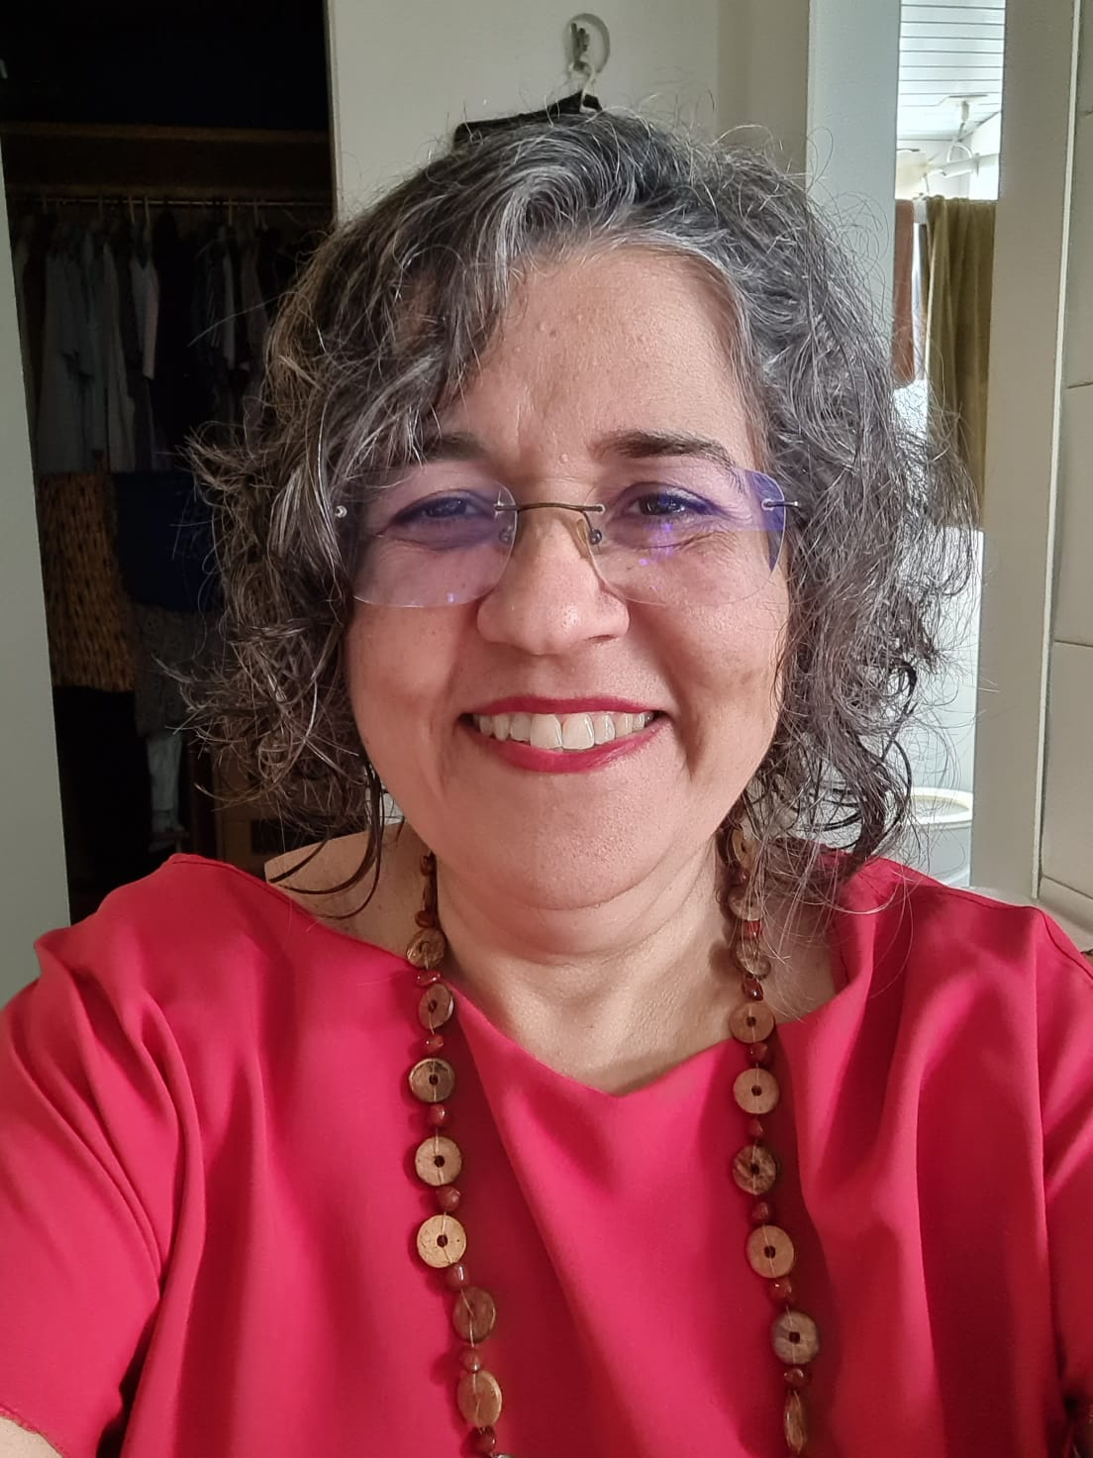

Full Name: **Aurea Silva de Holanda**

Google Scholar link: <https://scholar.google.com.br/citations?hl=pt-BR&user=uDGSnBEAAAAJ>

Linkedin link: --

Email: aurea@det.ufc.br

Area of Expertise: Engineering Education (Calculus teaching), Structural stability, Pavement mechanics

Faculty: Technology Center

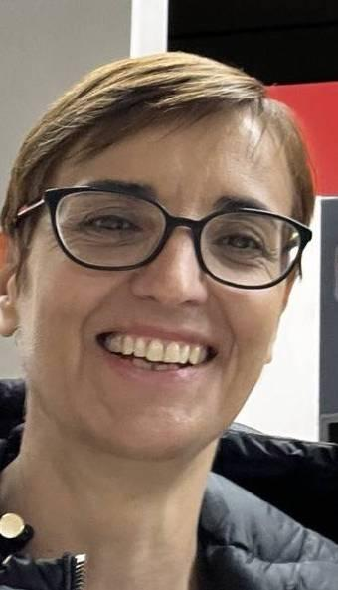

Full Name: **Michela Mulas**

Google Scholar link: <https://scholar.google.com/citations?hl=en&user=zzNZGU8AAAAJ>

Linkedin link: <https://fi.linkedin.com/in/michela-mulas-93a4739>

Email: [michela.mulas@ufc.br](mailto:michela.mulas@ufc.br)

Area of Expertise: Dynamical systems modeling and analysis; Control and optimisation of dynamical systems; Statistical modeling

Faculty: Technology Center